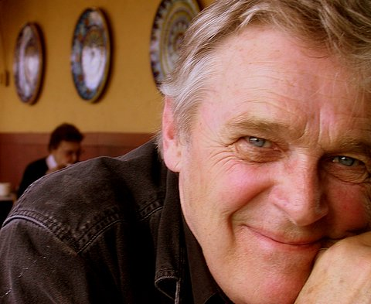

ELTON R EATON II

Elton R (Randy) Eaton, born to the Sterling Eatons of Plymouth, Michigan on December 10th 1940 in Detroit, passed away peacefully (01-28-2007) at home in his bed with his family close by. His father and grandfather both served in the Michigan Legislature and were distinguished Michigan weekly newspaper publishers. After attending Cranbrook School and the Universities of Miami and Michigan, Randy was pulled away by the family newspaper business, The Plymouth Mail, which he successfully took over and ran for many years.

In Randy’s own words, “I was happily married for 34 years to the beautiful, wonderful and amazing Gillian, with three amazing sons and a life lived, but way not complete. I worked as a newspaperman, football coach, TV commercial actor and brand model, created a swanky blues club in London's Covent Garden, worked as a criminal defense associate, PR guy, Montana horse wrangler, commercial photographer, and lastly with his sons at Thunderdog Studios (www.thunderdogstudios.com) on their brilliant toy manufacturing projects.” He wrote: “I've been broke, out of luck and in despair more than once. I out grew a couple of nasty strokes and a lot of bad habits. Best of my life has been (and still is) the relationship my sons and I have augured. My best friends, greatest supporters and dearest hearts are my sons. I like to think and wonder. I worry way less now that I know nothing is solid: everything (everything) is always tilting, rocking and morphing into something else. I find comfort in that. Dig it, really. This knowledge and the fact that nobody's responsible for your life but you, changes all sorts of shit. Being older rocks really good. I give a shit about a whole lot less (and a whole lot more) now at 65. If I have a moral rudder it is: cultivating friendliness and compassion. That, and this: Never Quit no matter the opposition.”

During the closing years of his life Randy founded the Detroit Men’s Club. Organized with the intention of encouraging area businessmen and artists to bring a total stranger to a bag lunch at unique and usually inaccessible locations, like back stage at the Detroit Opera House. In three years the club grew to over 200 members; and, many galleries owners, businessmen, artists and young entrepreneurs came to know each other. As Randy liked to say, “my goal is to show people they have more in common than they think; and, to uplift them if I can.”

He is survived by his wife Gillian a distinguished theater artist and their two beloved sons, Matthew (and his children Peri and Pierce) and Tristan (whose Thunderdog Studios in New York Randy helped found); another deeply loved son, Rob from a prior marriage also survives with two granddaughters (Alexandra and Roxanne). A chosen and adored daughter Leslie and her son Harrison live in Milwaukee. His dear sister Cynthia Eaton Johanson lives in Florida and has a son and daughter and one grand daughter.

Randy’s rich life was made more joyful by an astoundingly wide group of beloved friends and family in, Michigan, New York, Los Angeles, Tokyo, London, Wales and all over the States. He and his family are deeply grateful for their generous hearts and loving support especially during the final months of his illness. With true friends one is never alone.

There will be no funeral, but there will be a public remembrance in the near future. His ashes will be distributed in his favorite place during a private ceremony.

In the spirit of Randy’s life, and in lieu of sending flowers, the family requests well wishers to simply hand a twenty-dollar bill to a total stranger.

For more about Randy’s thoughts and inspirations try browsing Randy’s blog and My Space page, here are the links.

http://www.mylittlelookingglass.blogspot.com/

http://www.myspace.com/forrandyeaton

